**MINOR PROJECT - 2**

School of Computer Science

Cybernetics Cluster

UNIVERSITY OF PETROLEUM AND ENERGY STUDIES

DEHRADUN-248007, UTTARAKHAND

**SYNOPSIS REPORT**

For

**EduScan: Bridging Gaps in Villages**

Submitted By:

|  |  |  |
| --- | --- | --- |
| **Specialisation** | **SAP ID** | **Name** |
| DevOps (Hons) | 500091334 | Anushk Sanghvi |
| DevOps (NH) | 500095268 | Chitranshu Sharma |
| DevOps (NH) | 500095191 | Devesh Singh |
| DevOps (NH) | 500094899 | Raghav Mittal |

Dr. Arjun Arora Dr. Hitesh Kumar Sharma

**Project Mentor Cluster Head**

1. **Project Title**

EduScan: Bridging Gaps in Villages

1. **Abstract**

This project focuses on the real-life problems of rural villages student through a website or an QR based site which is “Edu Scan” an initiative aimed at bridging educational disparities in rural villages. In many parts of the world, access to qualify education remains a challenge, particularly in remote and underprivileged communities. This project is designed to address these gaps and empower village residents through education. Edu Scan facilitates personalized learning experiences that cater to the unique needs of each village. This project aims to create a supportive environment for both students and adults, fostering a culture of continuous learning. The ultimate goal is to create a sustainable model for educational empowerment in rural villages, ultimately bridging the gaps that hinder socio-economic progress.

1. **Introduction**

In the vast landscapes of rural villages, where the rhythm of life often unfolds amidst the serenity of nature, lies a persistent challenge: the gap in educational opportunities. The main motive of our project is to provide a sustainable platform to the rural village students who are not able to understand the things carefully or getting difficulty in catching the things and the challenges facing in rural villages are manifold, ranging from inadequate infrastructure to socio-economic barriers that hinder access to education. However, our agenda is that we can provide a platform through our QR based website which stands as a testament to the belief that every child, regardless of their geographical location or socio-economic background, deserves access to quality education.

We will design a website using the HTML and CSS for the frontend and node.js for the backend and in the website, we mainly focus on the 1 to 5 classes students of rural villages. We have created the different-different sections for the different classes so that every student is able to access them and we can also add some additional information related to the general knowledge, communication skills techniques so that students can also develop these skills side by side. We try to add the content in the form of animated or cartoon form so that when the student should access them, they would enjoy while learning. We can also add some quizzes, questions banks so that student should practice whatever the things they have learned so far.

Lastly, we use some DevOps tools to deploy our whole website we use terraform, ansible and if we want any other tool then we use Kubernetes for deploying and orchestrate our website.

Our main agenda is to make education easy for the rural villages student who think that education is a very heavy burden or they don’t understand the things easily, so make easy and make knowledgeable.

**AGENDA – “MAKE EASY AND MAKE KNOWLEDGEABLE”**

1. **Literature Review**

Rural education faces numerous challenges, including limited access to quality infrastructure, shortage of qualified teachers, socio-economic barriers, and lack of technological resources These challenges contribute to disparities in educational outcomes and perpetuate cycles of poverty and inequality in rural communities.

Technology plays a transformative role in addressing educational challenges in rural areas. Digital platforms, online learning tools, and mobile technologies offer opportunities to expand access to educational resources and facilitate personalized learning experiences (Davis & Pearce, 2019). By leveraging technology, educational interventions can reach remote villages and provide students with interactive and engaging learning opportunities.

Several case studies highlight successful educational interventions in rural areas that share similarities with the Edu Scan initiative. The Digital Study Hall project in India demonstrates the effectiveness of video-based learning in improving educational outcomes in remote villages (Abhijit & Rukmini, 2018). Similarly, the Bridge Academy model in Africa emphasizes low-cost, scalable solutions for delivering quality education in underserved communities.

1. **Problem Statement**
2. **Limited Access to Quality Infrastructure**: Rural villages often lack proper school buildings, classrooms, libraries, and other educational facilities.
3. **Shortage of Qualified Teachers:** Rural areas struggle to attract and retain qualified teachers due to lower salaries, limited professional development opportunities, and isolation from urban centers.
4. **Socioeconomic Barriers:** Students from lower-income families face challenges accessing educational resources, including books, uniforms, and transportation.
5. **Limited Curriculum and Extracurricular Activities:** Rural schools may offer a limited range of courses and extracurricular activities due to resource constraints.This limitation can impede students' ability to explore diverse interests and develop essential skills beyond academics.
6. **Geographical Isolation:** Schools located in remote areas face challenges in terms of accessibility, transportation, and connectivity. Geographic isolation also affects teacher recruitment and professional development opportunities.
7. **Objective**
8. Expanding Access to Quality Education.
9. Fostering Community Engagement and Empowerment.
10. Enhancing Educational Outcomes.
11. Deploying our website using DevOps Tools.
12. **Methodology**

* Agile methodology is an iterative approach to software development and project management that emphasizes flexibility, collaboration, and customer feedback.
* The project is broken down into small, manageable chunks called iterations or sprints. Each sprint typically lasts for a few weeks and results in a potentially shippable product increment.
* Agile allows for changes to be incorporated throughout the development process which makes our project more flexible and adaptable.
* Agile promotes continuous improvement through regular reflection and adaptation. At the end of each sprint, the team conducts a retrospective to identify what went well, what could be improved, and any adjustments needed for future sprints. This allows the team to respond to lessons learned and refine their approach over time.

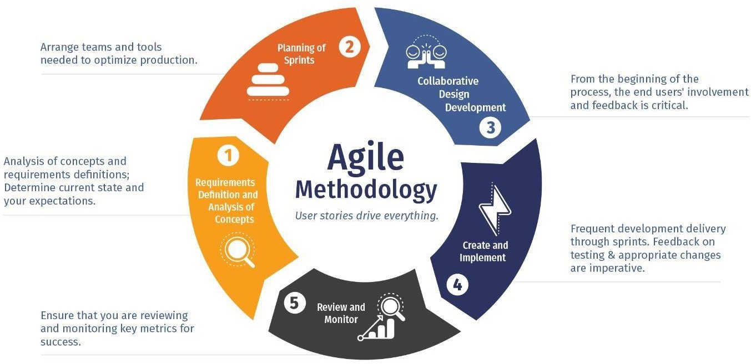

1. **Technology Stack:**

* **Front-End Development:** HTML, CSS, JavaScript
* **Back-End Development:** Node.js for server-side logic
* **Database:** NoSQL Data Base- MongoDB for Data Base storage
* **Version Control:** Git and GitHub for code versioning and collaboration
* **Hosting and Deployment:** Vercel or AWS
* **DevOps Tools:** Terraform, Ansible, Jenkins, Docker, Git
* **Development Environment:** Integrated Development Environments (IDEs) such as Visual Studio Code or PyCharm
* **Animating the Content:** Blender

1. **SWOT Analysis**

**Strengths:**

1. **Innovative Approach:** The project utilizes technology, specifically a QR-based website, to deliver educational content to rural villages, which can effectively bridge the gap in educational opportunities.
2. **Personalized Learning:** By offering content tailored to the unique needs of each village and student, the project can address specific educational challenges effectively.
3. **Community Engagement:** The initiative aims to foster community engagement and empowerment, which can lead to greater support and sustainability of the project.
4. **Agile Methodology:** The adoption of Agile methodology allows for flexibility, collaboration, and continuous improvement throughout the development process.

**Weaknesses:**

1. **Technological Barriers:** Limited access to technology or internet connectivity in rural areas may hinder the effectiveness of the QR-based website.
2. **Resource Constraints:** Rural villages often face resource constraints, including financial limitations and infrastructure challenges, which could impact the implementation and scalability of the project.
3. **Quality Assurance:** Ensuring the quality and accuracy of educational content, especially when delivered through digital platforms, may pose challenges and require ongoing monitoring and evaluation.
4. **Dependency on Volunteers:** The success of community engagement initiatives may rely heavily on the availability and commitment of volunteers, which could be inconsistent.

**Opportunities:**

1. **Partnerships:** Collaborating with local organizations, governments, or NGOs can provide opportunities for resource sharing, funding, and scalability.
2. **Expansion of Services:** The project can expand its services beyond educational content delivery to include additional support, such as vocational training or healthcare initiatives, further enhancing its impact.
3. **Technological Advancements:** Advancements in technology, such as improved internet connectivity or mobile penetration, can create new opportunities to reach more remote villages effectively.
4. **Policy Support:** Advocacy for policies that prioritize education in rural areas can create a supportive environment for the project's objectives and sustainability.

**Threats:**

1. **Economic Instability:** Economic downturns or financial crises can affect funding availability, potentially jeopardizing the project's sustainability.
2. **Cultural Resistance:** Cultural norms or attitudes towards education may pose barriers to community engagement or acceptance of the project.
3. **Political Instability:** Political unrest or changes in government priorities may disrupt project implementation or funding support.
4. **Competition:** Competition from other educational initiatives or programs targeting rural areas may pose challenges in attracting and retaining beneficiaries.
5. **PERT Chart**

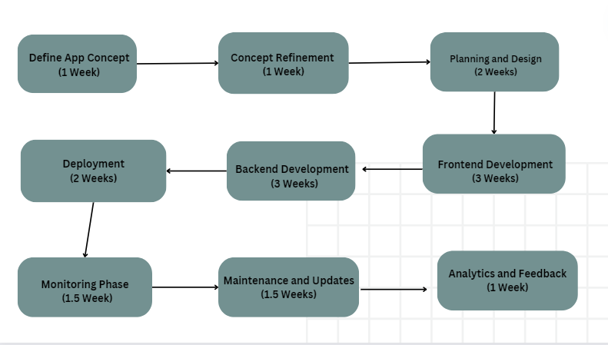

1. **References**
2. Abhijit, B., & Rukmini, B. (2018). Digital Study Hall: An Innovative Education Model for Rural India. Journal of Educational Technology, 15(2), 45-58.
3. Bruns, B., Filmer, D., & Patrinos, H. A. (2018). Making Schools Work: New Evidence on Accountability Reforms. The World Bank.
4. Davis, N. E., & Pearce, J. (2019). Scaling up Mobile Learning: Leveraging Community Networks. Journal of Interactive Media in Education, 1(2), 34-47
5. **Ground Survey**

